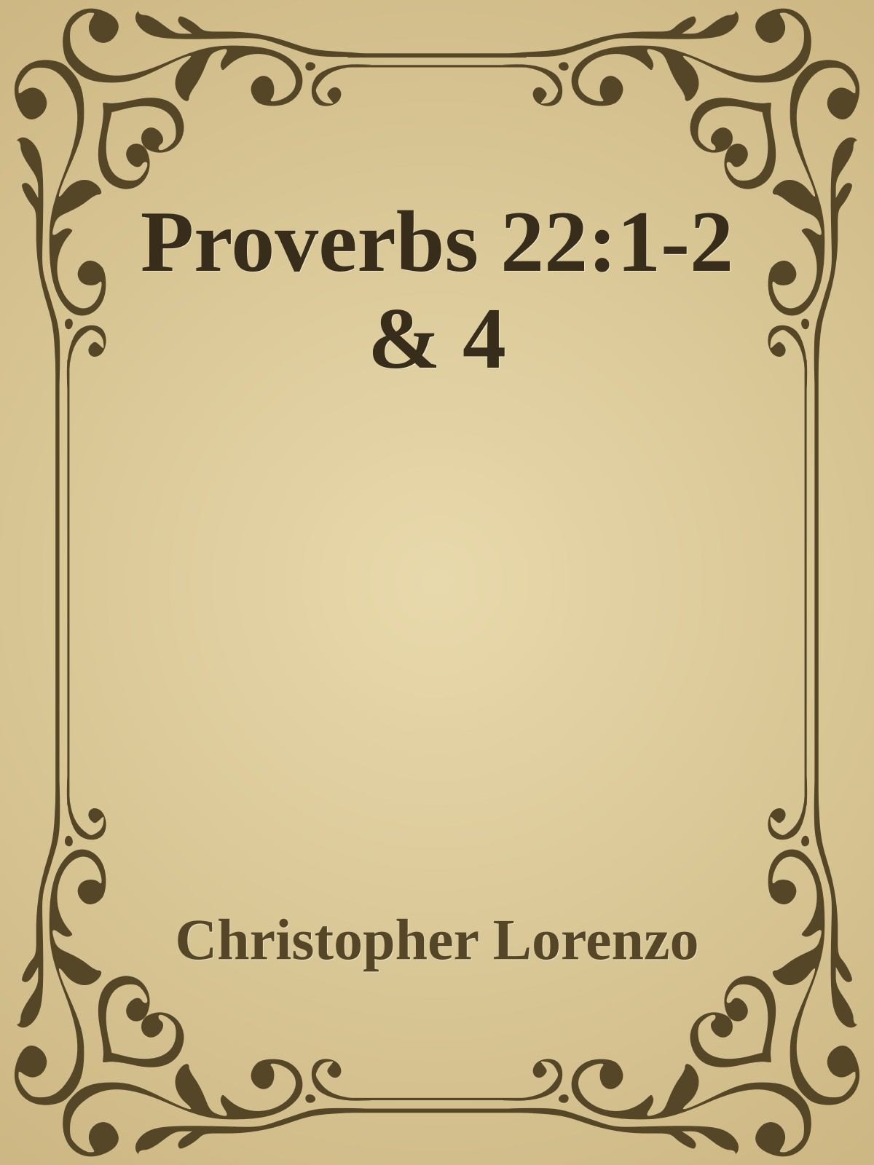

Proverbs 22:1-2 & 4

1. A good name is to be chosen rather than great wealth, good favor more than silver or gold. 2. The rich and the poor are met together; the Lord is the Creator of them both. 4. The reward for humility and fearing the Lord is riches and honor and life.

What is in a name? Or what does reputation have to do with anything? If you have a bad name somewhere or a bad reputation you could simply just move and “create a new identity” right? Not really. Especially in today’s society with social media and the internet it is hard to get away from a bad reputation and easier to ruin a good reputation. A person may try to change their reputation but bad habits are hard to break and the truth will eventually come out.

In these selected proverbs from Soloman we see what is more important in this life. We see that a good reputation or a good name is preferable to wealth, and whether a good reputation while being poor or a bad reputation while being rich, both will end up in the same place. Everyone, everywhere will have to stand before Jesus Christ when they die. Worldly wealth does not matter, worldly knowledge is not taken into account, in fact the only thing that matters when you stand before God is whether your name is written in the Lambs book of Life. That is truly all that matters at the end of the day.

I choose the last verse, verse 4 because of what a life of humility towards the Lord results in, it results in life eternal. It results in riches and honor and life. All three are achieved when the Christian dies and gets to heaven. Although Heaven will not be the same for everyone, it will be glorious for everyone. We will all meet God at the end and for me personally I cannot wait for that day to come.

Remember this week to think of things on the glories that are awaiting us on the other side of eternity. Everything from cars and houses and riches on this side of heaven will all evaporate and fade away, but your soul will continue on for eternity either in Heaven or in Hell. Keep your eyes on Christ and keep in your Words as Christ’s very words of life are written in them. And as always keep all of us here at New Life in your prayers.